**Assignment 18.2**

Below is the dataset which we will be using for this Assignment in all problems. It has been kept in local file system:-

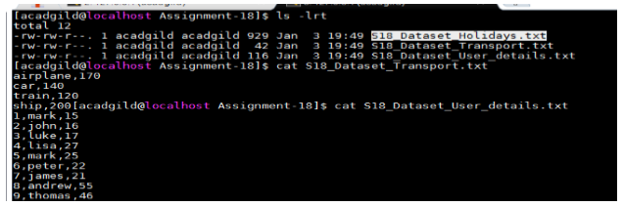

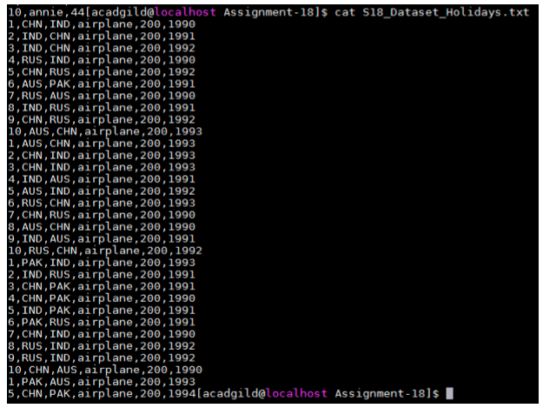

DataSet is uploaded in as follows:-

* val baseRDD1 = sc.textFile("/home/acadgild/Assignment18/S18_Dataset_Holidays.txt")
* val baseRDD2 = sc.textFile("/home/acadgild/Assignment18/S18_Dataset_Transport.txt")
* val baseRDD3 = sc.textFile("/home/acadgild/Assignment18/S18_Dataset_User_details.txt")
* import org.apache.spark.storage.StorageLevel
* baseRDD1.persist(StorageLevel.MEMORY_ONLY)
* baseRDD2.persist(StorageLevel.MEMORY_ONLY)
* baseRDD3.persist(StorageLevel.MEMORY_ONLY)

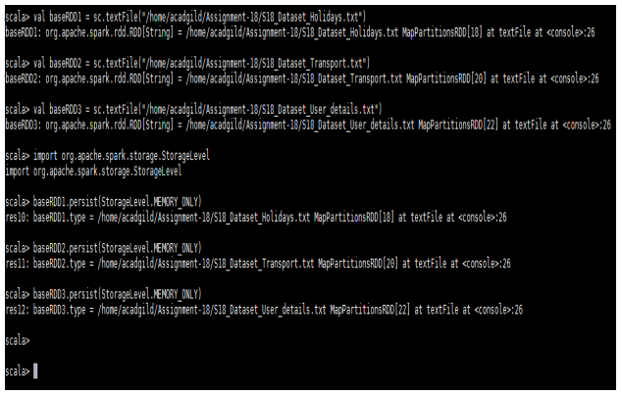

Problem Statement:-

1. Which route is generating the most revenue per year

2. What is the total amount spent by every user on air-travel per year

3. Considering age groups of < 20 , 20-35, 35 > ,Which age group is travelling the most every year.

Solution:-

* Which route is generating the most revenue per year

Below is the code used:-

* val travel = baseRDD1.map(x => (x.split(",")(0).toInt,x.split(",")(1),x.split(",")(2),x.split(",")(3),x.split(",")(4) .toInt,x.split(",")(5).toInt))
* val transport = baseRDD2.map(x => (x.split(",")(0),x.split(",")(1).toInt))
* val user = baseRDD3.map(x => (x.split(",")(0).toInt,x.split(",")(1),x.split(",")(2).toInt))
* val travelmap = travel.map(x=> x._4 -> (x._2,x._5,x._6))
* val transportmap = transport.map(x=> x._1 -> x._2)
* val join1 = travelmap.join(transportmap)
* val routeMap = join1.map(x => (x._2._1._1 -> x._2._1._3) -> (x._2._1._2 * x._2._2))
* val costsum = routeMap.groupByKey().map(x => x._2.sum -> x._1)
* val sortRevenue = costsum.sortByKey(false).first()

Output:-

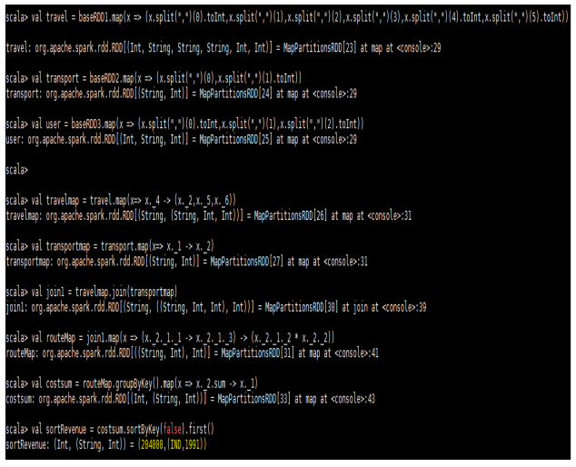

* What is the total amount spent by every user on air-travel per year

Below is the code used:-

* val userMap = travel.map(x => x._4 -> (x._1,x._5,x._6))
* val amtMap = userMap.join(transportmap)
* val spendMap = amtMap.map(x => (x._2._1._1, x._2._1._3) -> (x._2._1._2 * x._2._2))
* val total = spendMap.groupByKey().map(x => x._1 -> x._2.sum)
* total.foreach(println)

Output:-

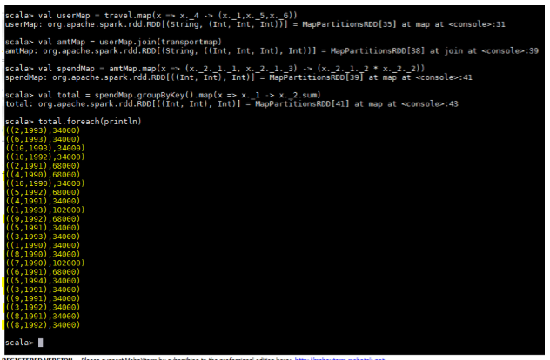

* Considering age groups of < 20 , 20-35, 35 > ,Which age group is travelling the most every year.

Below is the code used:-

* val AgeMap = user.map(x => x._1 -> {if(x._3<20) "20" else if(x._3>35) "35" else "20-35" })
* val UIDMap = travel.map(x => x._1 -> 1)
* val joinMap = AgeMap.join(UIDMap)
* val joinMap2 = joinMap.map(x => x._2._1 -> x._2._2)
* val groupKey = joinMap2.groupByKey.map(x => x._1 -> x._2.sum)
* val maxVal = groupKey.sortBy(x => -x._2).first()

Output:-

